MANGOCHI CATHOLIC DIOCESE MOCK EXAMINATIONS

2025 MALAWI SCHOOL CERTIFICATE OF EDUCATION
AGRICULTURE
Subject Number: M 012/II
Monday, 26 May 2025 Time Allowed: 1 hour 30 min
10:00 am onwards
PAPER II
(100 marks)
Questions  Answered | Tick if  Answered | Do not write in this column
1
2
3
4
Total
INSTRUCTIONS

- This paper has 6 pages. Please check.
- The maximum number of marks for each answer is indicated against each question.
- Write your answers in the spaces provided on the question paper
- In the table provided on this page tick against the question number you have answered
- Please make sure that you Examination Number on top of all pages in this paper before you start answering question

© 2025 MH DIOCESE Turn Over
SECTION A 20 MARKS
1. Describe an experiment in which a student can carry out to determine soil pH using universal indicator. In your description include materials, procedure and expected results.

Materials
____________________________________________________________________________________________________________________________________________________________________________________________________________________________________________________________________________________________________________________________________________________________________________________________ ( 3 marks)

Procedure
___________________________________________________________________________________________________________________________________________________________________________________________________________________________________________________________________________________________________________________________________________________________________________________________________________________________________________________________________________________________________________________________________________________________________________________________________________________________________________________________________________________________________________________________________________________________________________________________________( 4 marks)
Expected results
___________________________________________________________________________________________________________________________________________________________________________________________________________________________________________________________________________________________________________________________________________________________________________________________________________________________________________________________________________( 3 marks)
Continued/…

2. The table below shows the yield obtained on an experimental plot for different varieties of maize and quantity of manure applied. Use it to answer the questions which follow.
Farm yard Manure (kg) | Hybrid Maize (kg) | Local Maize (kg)
0 | 900 | 700
100 | 1000 | 800
200 | 1100 | 900
300 | 1250 | 1000
400 | 1400 | 1200
500 | 1500 | 1300
600 | 1600 | 1400
700 | 1700 | 1400
800 | 1800 | 1400

- Draw a line graph on the varieties of maize against farm yard manure (4 marks)

Continued/…
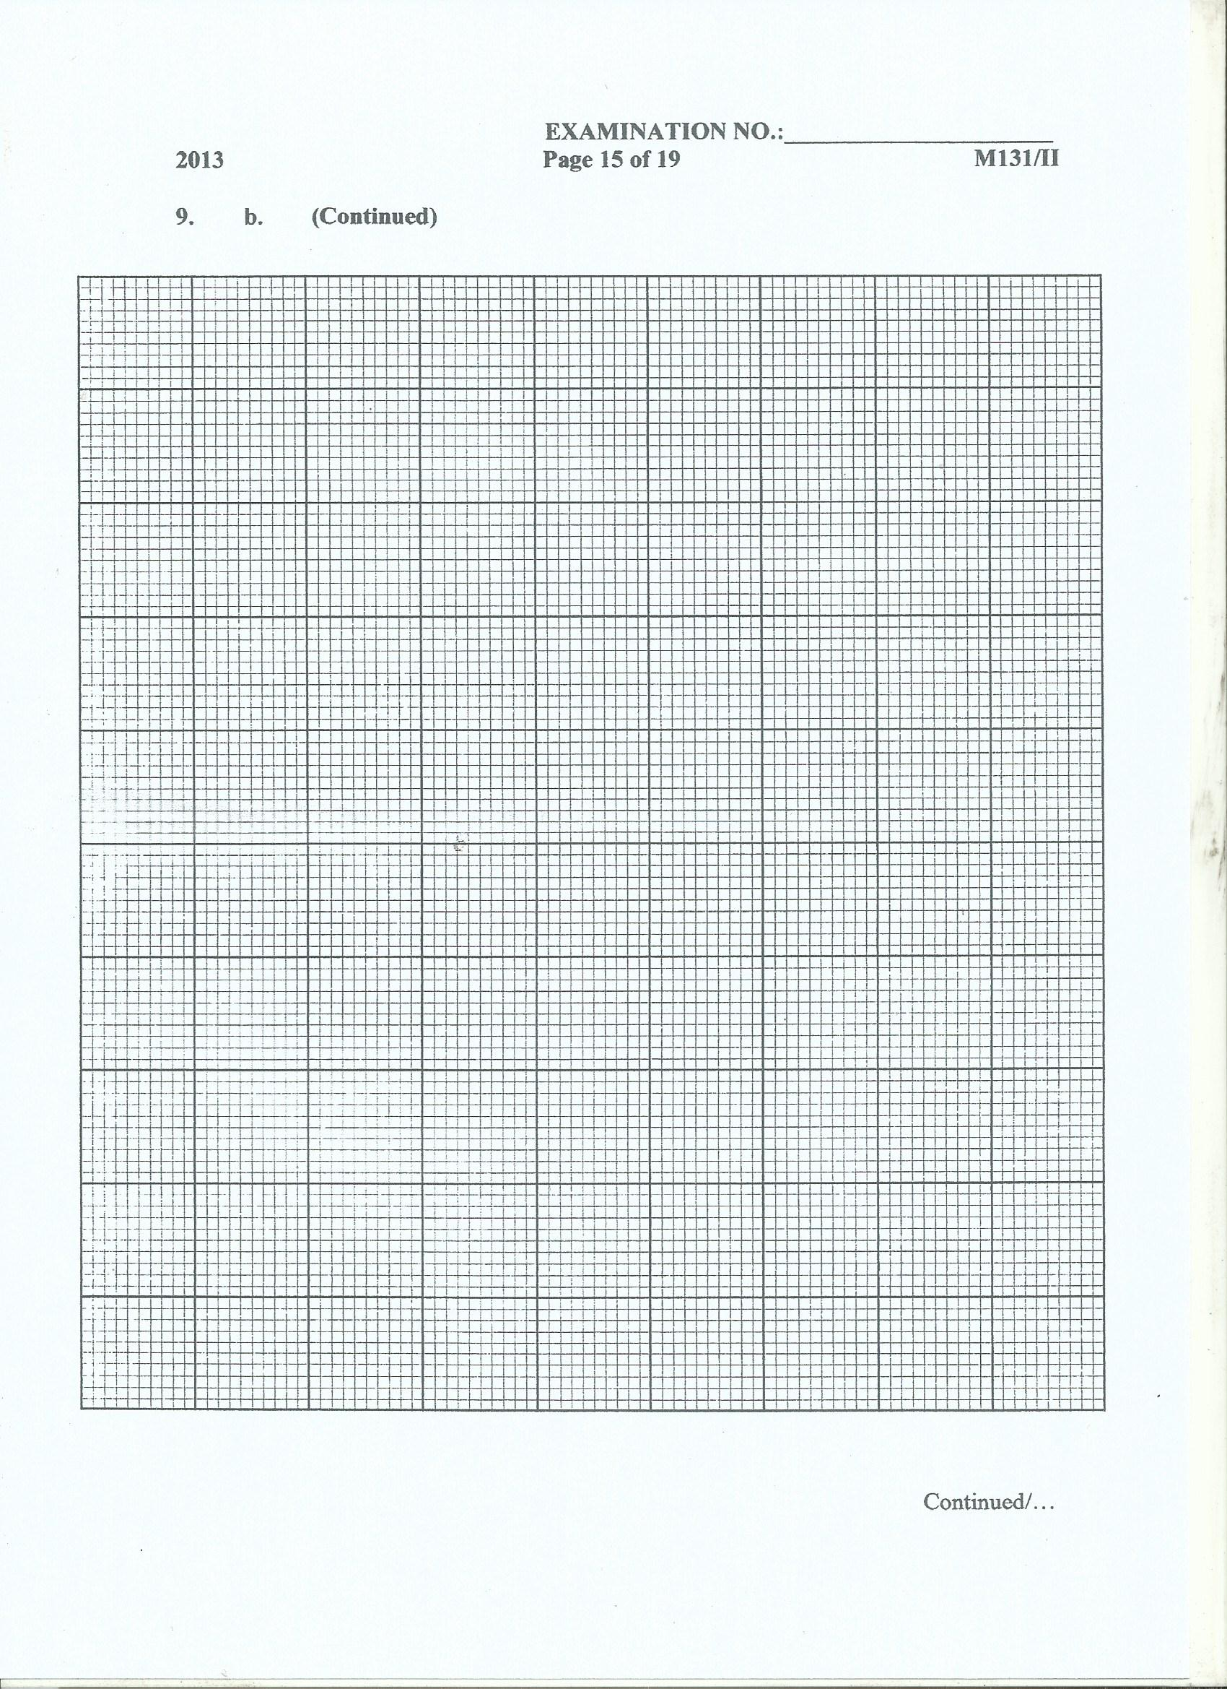
- What was the aim of the experiment?
_____________________________________________________________________(1 mark)
c. From the graph, what yield was obtained from each variety for an application rate of 65 kg of farm yard manure?
- Hybrid maize _______________________________________________(1mark)
Continued/…

- Local maize ________________________________________________(1mark)
iii. Give the reason why hybrid maize performed better than local maize at the same farm yard manure application rates.
_______________________________________________________________________
_____________________________________________________________________( 1 mark)

d. (i) What could happen to both hybrid and local maize if the farmer kept on increasing application of manure beyond 800 kgs?
_____________________________________________________________________ ( 1 mark)
ii. Give the reason for your answer in question d (i) above.
_____________________________________________________________________
____________________________________________________________________( 1 mark)
SECTION B 20 MARKS
3. You are provided with samples labeled K, L and M.
a. Identify specimen K.
_____________________________________________________________________( 1 mark)

b. Name the sample that can be an additive feed to livestock.
_____________________________________________________________________( 1mark)
c. What is the importance of adding specimen M to soil?
___________________________________________________________________ ( 1 mark)
d. Name one way of propagating specimen L.
____________________________________________________________________ ( 1 mark)
e. Give two disadvantages of the type of propagation which specimen L undergoes.
_______________________________________________________________________________________________________________________________________________________________________________________________________________________________________________________________________________________________________________( 2 marks)
f. Name the degree of elasticity of demand in which specimen K belongs.
_____________________________________________________________________ (1 mark)
Continued/…
g. Sketch the graph of degree of elasticity of demand in which specimen K belongs. (3 marks)

4. You are provided with specimens B and C
(a) Identify the specimens B and C
___________________________________________________________________(1 mark)
(b) What is the common method of applying specimen C to a field of genetically modified maize?
___________________________________________________________________ (1 mark)
(c) State two advantages of using the common method of applying specimen B to a field of genetically modified maize?
(i)__________________________________________________________________ (1 mark)
(ii)__________________________________________________________________ (1 mark) (d) Give any one way in which nitrogen in specimen B can be taken by crops.
_____________________________________________________________________ (1mark)
(e) Mention any two uses of any two elements in specimen C for crop production.
_____________________________________________________________________ (1mark)
_____________________________________________________________________ (1mark)
(f). Mr Phiri applied four bags of fertilizer weighing 50 kg to his crops . Calculate the amount of nitrogen this farmer applied. Show your working.

(3marks)
END OF QUESTION PAPER
NB: This paper contains 6 printed pages

